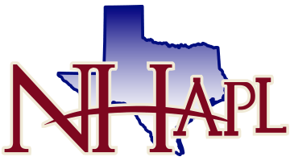
Sponsorship Form 2015 NHAPL Fall Member Social
Hosted at Top Golf Spring
Thursday, September 10, 2015

Dear Sponsor:
We are offering you and your company the opportunity to be a sponsor at the annual NHAPL Fall Member Social to be held at the Top Golf in Spring Texas. This year’s event will be held on Thursday, September 10, 2010. The event provides an excellent opportunity to network with fellow landmen and enjoy great fellowship with friends. We are currently seeking sponsors for each of the categories listed below. This allows your company maximum exposure and the opportunity to promote your business. We hope will take advantage of the below sponsorship levels:

Platinum Sponsor - $1,500 – own slide on sponsor slideshow shown on TV’s at event, prominent placement on sign up page at www.NHAPL.org, ability to bring own banner and/or promotional items to event
Gold Sponsor - $1,000 – own slide on sponsor slideshow shown on TV’s at event, placement on sign up page at www.NHAPL.org
Silver Sponsor - $750 – shown on silver sponsor slide on slideshow shown on TV’s at event
Food Sponsor - $750 – shown on beverage/food sponsor slide on slideshow at event (limited to one sponsor)
Beverage Sponsor - $750 - shown on beverage/food sponsor slide on slideshow at event (limited to one sponsor)
Bay Sponsor - $250 – company shown on sign to be placed at bay (4 bays available)

List your Type of Sponsorship(s):

Amount Enclosed:

MAKE CHECKS PAYABLE TO: North Houston Association of Professional Landmen

Mail to: NHAPL
P.O. Box 673065
Houston, TX 77267
Attn: Topgolf Social

